Sticky Notes
Find this app in the windows store. It is free and here is the store reference:
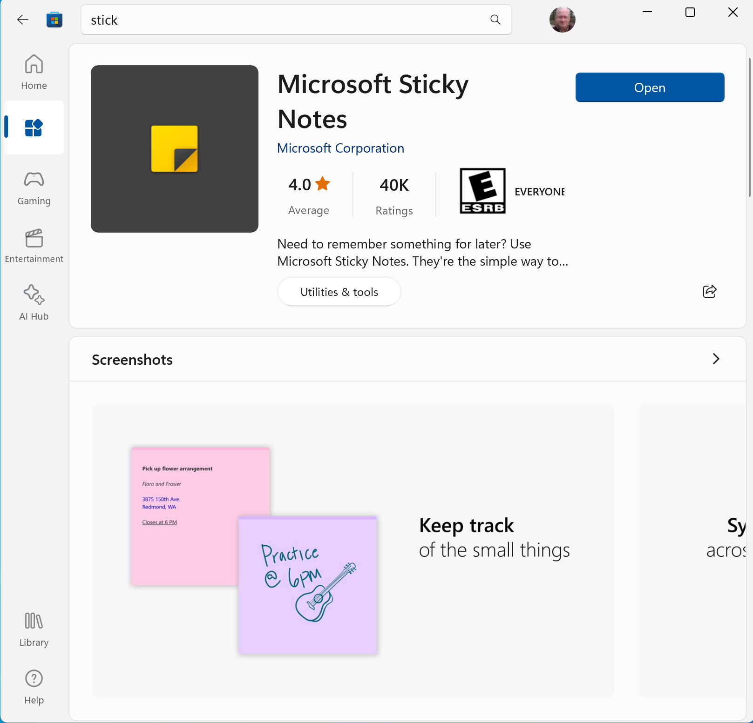

After clicking the install button you can go to your APPs window, search for it and I suggest add it to your taskbar:
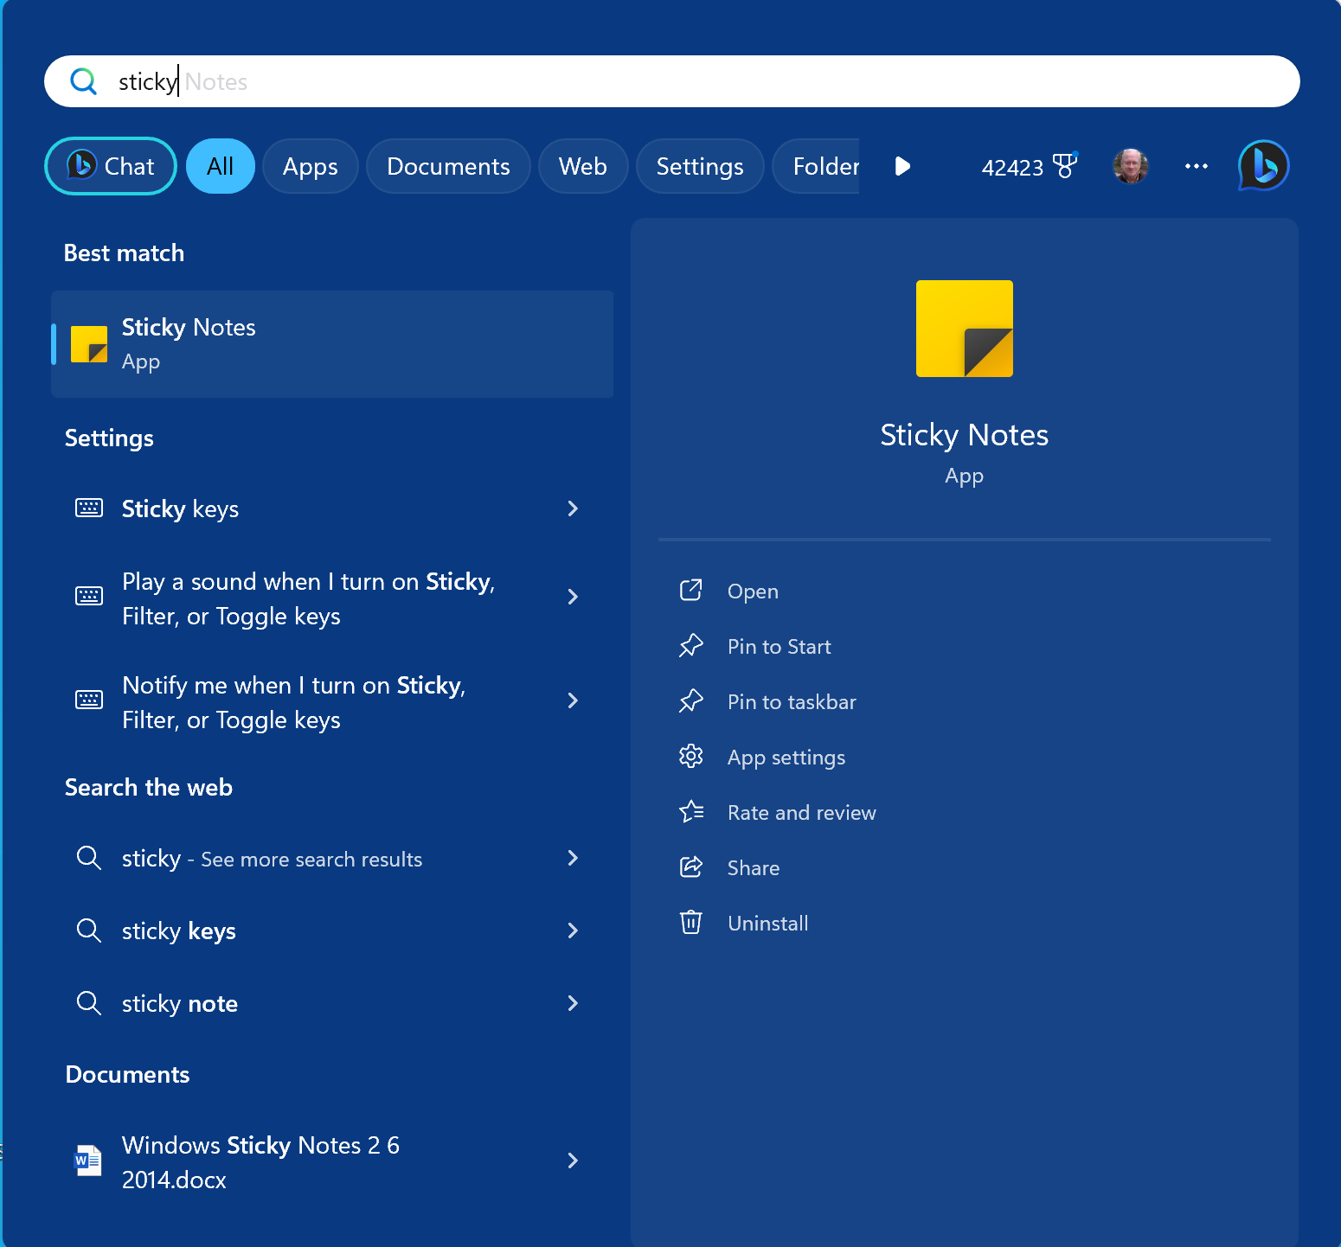
Then open the app. Click on the yellow note that appears:
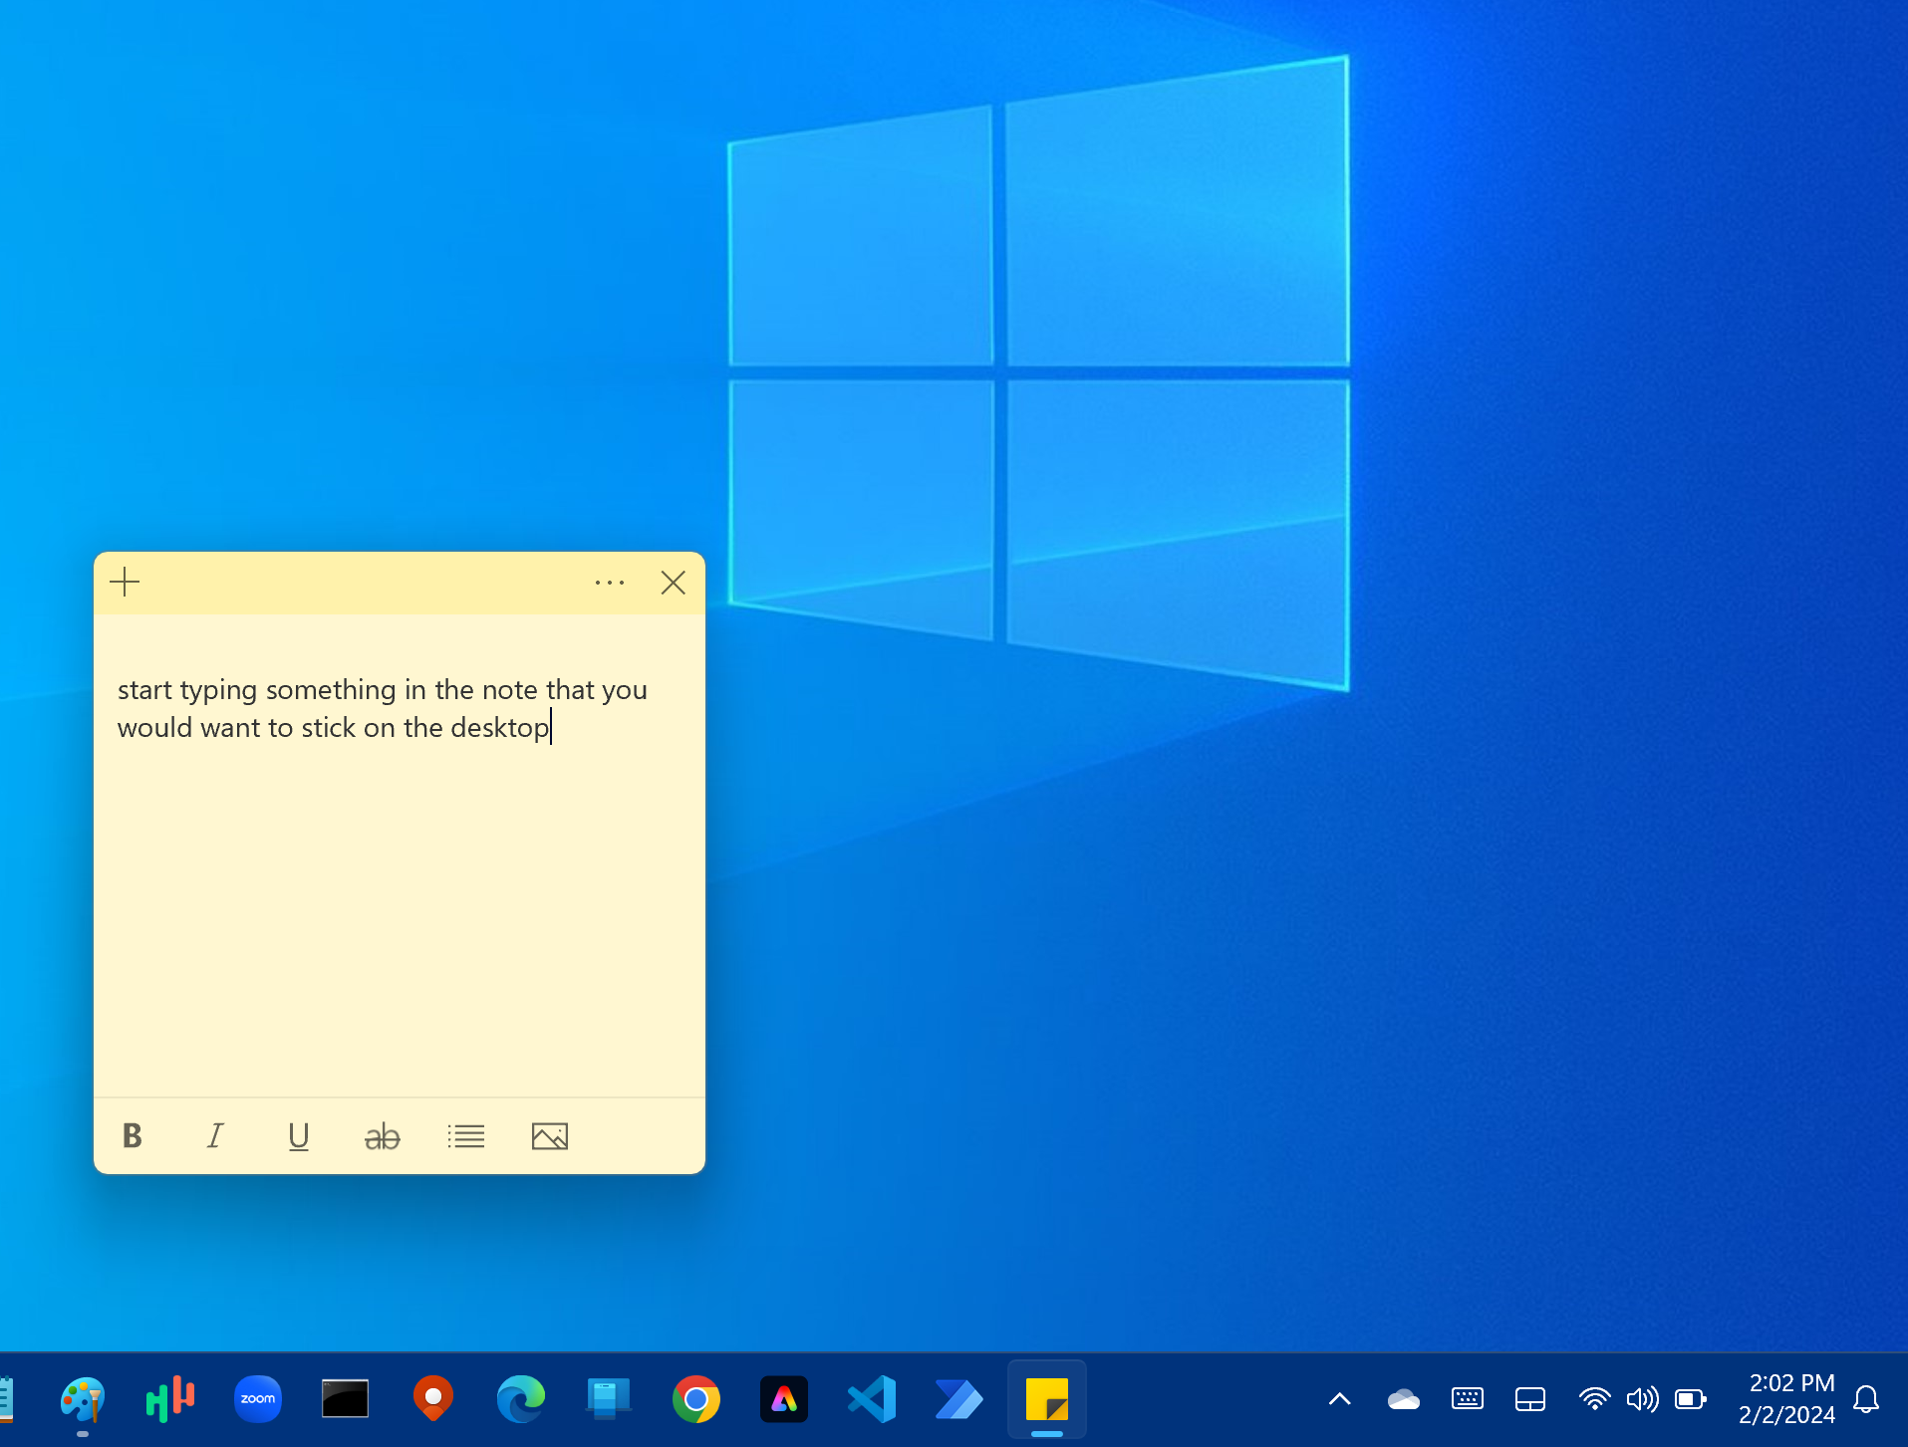

There are some icons to provide edit functions at the bottom of the note. Use the … (3 dots) to delete this note.

Use the + sign to open another note.

The 3 dots also offer you several colors to select for the background. Yellow is shown here.

When you restart your PC this note will appear on the desktop as you see above.

